**Network Switch**

* On Desktop
* Enter Network-Switch folder
* Then double click on switcher.sh
* Click “Execute in Terminal” (should get a visual screen)
* Move up and down with Arrow keys  
  then press Enter on option wanted be it Hub or Wifi

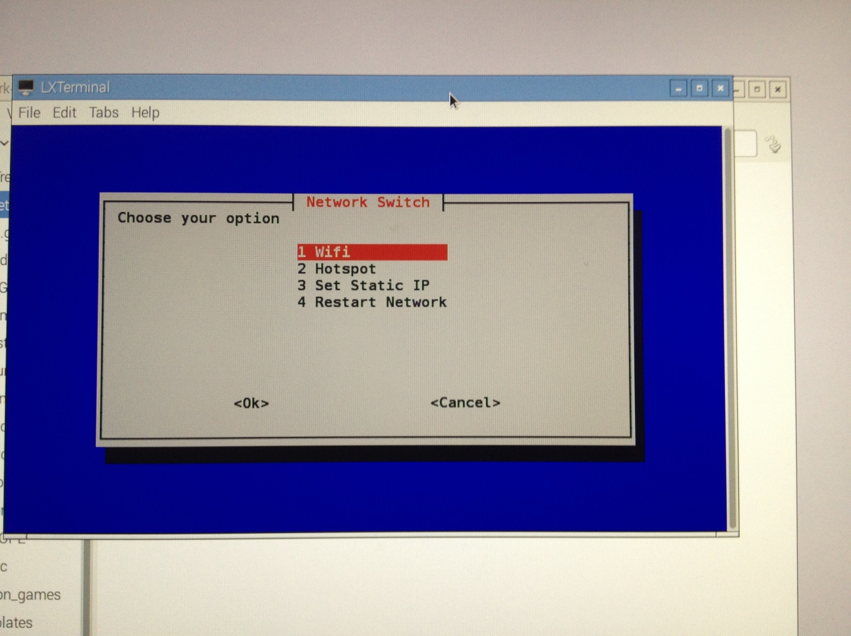Robot = Hotspot

Communications = Wifi

* Click Enter again to confirm it has finished if need to  
   then swap will have been performed.